City of Fairfield
COVID-19 Rental Relief and Eviction Prevention Resource Guide

Shelter Inc. Eviction Prevention Rental Assistance
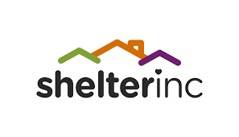Assist low-income City of Fairfield residents who are experiencing a financial hardship due to the COVID-19 Pandemic and need rental assist or utility assistance.
For more information visit: www.shelterinc.org/renthelp

Legal Services of Northern California
Offers free services to counsel tenants on their legal rights, advocate for tenants in resolving rental dispute before evictions, assist tenants in representing themselves in eviction proceedings, negotiate settlements in eviction proceedings, and provide limited representation in eviction proceedings.
Fairfield residents may call 707-643-0054 for assistance
Project Sentinel-Tenant/landlord counseling
Offer free housing counseling, conciliation, and mediation to anyone involved in a housing dispute. As a neutral agency, Project Sentinel provides legal information and administers a panel of professional mediators who assist parties with issues around termination, security deposits, habitability, maintenance/repairs, and beyond.
Fairfield residents can call 707-410-4003 or send an email to fairfield@housing.org for assistance.

Housing is Key
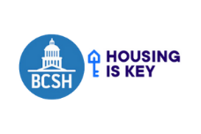 The Rent Relief Program pays eligible tenants and landlords 100% of a tenant’s past-due rent and utilities going as far back as April 1, 2020. The program is free and does not currently have a deadline, but because funding may be limited, renters are encouraged to apply as soon as possible if they know they may struggle to cover past or prospective rent and utilities.
For more information visit: https://housing.ca.gov/

