**PUBLIC HEARING NOTICE**

**ZONING ADMINISTRATOR**

**NOTICE IS HEREBY GIVEN THAT THE ZONING ADMINISTRATOR OF THE CITY OF FAIRFIELD** will hold a public hearing on the following item:

**997 Beck Avenue Child Day Care Use Permit – Conditional Use Permit (UP2022-009) and Environmental Review (ER2022-038).** Public hearing on the request by Ken Stewart to allow for the operation of a child day care center within the Service Commercial (CS) Zoning District on the property at 997 Beck Avenue (APN: 0028-101-180). The project has been deemed Categorically Exempt under CEQA Section 15301 Existing Facilities. (Planner: Yee-Lynn Wong, 707-428-7449, ywong@fairfield.ca.gov)

**NOTICE IS HEREBY FURTHER GIVEN THAT** said public hearing will be held on **WEDNESDAY, JANUARY 18, 2023,** beginning at **2:00 pm** on the 2nd Floor of Fairfield City Hall at 1000 Webster Street at which time and place any and all persons interested in said matters may appear and be heard. If you challenge any of the above-cited items in court, you may be limited to raising only those issues you or someone else raised at the public hearing described in this notice, or in written correspondence delivered to the Community Development Department at, or prior to the public hearing. Any party aggrieved or affected by a decision or determination by the Zoning Administrator in the administration of the City’s Development Regulations may file an appeal within 14 business days of the decision or determination using the appeal form available from the Community Development Department. To file an appeal, complete the form and submit it with the appropriate fee to Community Development Department, 1000 Webster Street, 2nd Floor, Fairfield, CA 94533 no later than 14 business days from the date of this hearing. Postmarks will be accepted. For additional information, please contact the Community Development Department, City Hall, 2nd Floor, or phone 707-428-7440.

The City of Fairfield does not discriminate against any individual with a disability. City publications will be made available upon request in the appropriate format to persons with a disability. If you need accommodation to attend or participate in this meeting due to a disability, please contact Cindy Garcia, Office Specialist, 707-428-7452, cgarcia@fairfield.ca.gov, in advance of the meeting.

**TO BE PUBLISHED BY THE DAILY REPUBLIC ON: FRIDAY, JANUARY 6, 2022**

**BILL TO: CITY OF FAIRFIELD COMMUNITY DEVELOPMENT**

**Project Vicinity**

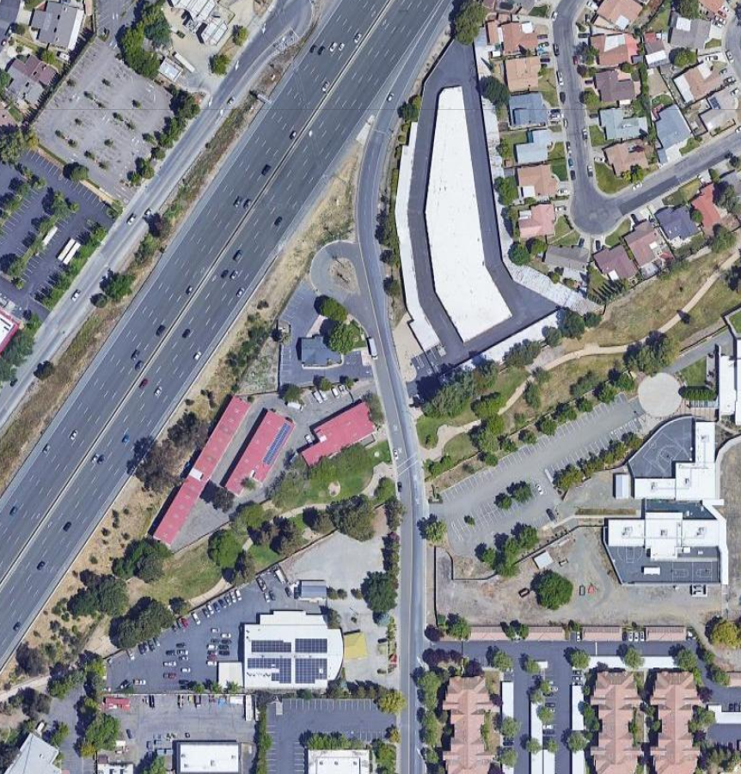

SITE